

Inpatient Booklet - York Hull CF Centre

Information for people with Cystic Fibrosis, their relatives, and carers

i For more information, please contact:
York Hull Adult Cystic Fibrosis Centre
York Cystic Fibrosis Centre
Telephone: 01904 725601
E-mail: yhs-tr.yhachc@nhs.net
The York Hospital
Wigginton Road, York, YO31 8HE

Hull Cystic Fibrosis Centre
Telephone: 01482 622495
Email: yhs-tr.yhacfc@nhs.net
Castle Hill Hospital
Castle Road, Cottingham, Hull, HU16 5JQ
Web: www.cfyork.org.uk
Facebook: https://www.facebook.com/cysticfibrosisyork
Index |  | Page
Contents 1
Page 1
What to expect as an inpatient 3
Looking after yourself 5
Reduced cost or free of charge services 6
York and Hull Hospital Inpatient Wi-Fi ‘How to...’ 8
Catering: Food and Snacks 9
Ward 34 9
CF Team: Nursing 12
CF Team: Physiotherapy 14
CF Team: Pharmacy 15
CF Team: Clinical Psychology 16
CF Team: Dietetics 17
Self-Medication 18
Cystic Fibrosis Trust: Financial Support Service 19
Local Amenities 19
Discharge 22
Contacting The Cystic Fibrosis Team 23
Visiting Hours 24

What to expect as an inpatient

If you need to be admitted to hospital, we recognise this can be an incredibly stressful time, and this leaflet aims to answer some questions and make things easier for you. Remember your CF team and the ward team are always there if you have any concerns.

Admissions may be planned or urgent; your first point of contact will usually be the CF specialist nurse or physiotherapist.

Your care will be coordinated with the CF team doctor, nurse, physiotherapist, and ward staff, with input from other specialists as required. The ward team work closely with the CF specialist team and are used to looking after people living with CF.

As we are a teaching hospital, there may also be students on the ward. It is your choice whether you see them or not.

CF inpatients are usually admitted into side rooms to avoid cross-infection.

It is particularly important to maintain calorie intake, and so fridges are available in every room to allow you to keep drinks and snacks fresh.

It can be difficult to keep up exercise while in a side room. Physiotherapy advice will be available as well as exercise equipment.
Your first day

If your admission has been planned between the hours of 8am and 4pm Monday – Friday, a member of the CF team will be available to meet you on the ward and show you to your room. If your admission is out of hours, the ward staff will be aware of your arrival and will help you settle onto the ward.

You will usually be seen by one of the junior doctors, who will take your medical history, and examine you.

The ward nurses will also see you to check all your observations, and to find out more about you.

The first day can sometimes be busy, with blood tests and investigations and lots of different people asking you different questions.

Looking after yourself

It is important that you have sufficient rest and sleep whilst you are in hospital. The ward can be a busy place, with a variety of health care professionals coming to visit you.

If you would like specific times of rest, then please let the ward staff and the CF team know, and we will do our best to accommodate your wishes. For example, the CF team have an exercise bike, if you would like access to this in your room for the duration of your stay, please let us know.

If you are feeling well enough, it is also helpful to get out of the ward for a walk or change of scenery, and we would encourage this. Please let the ward staff know where you will be. There are some lovely outside spaces and gardens you can use.

Reduced cost or free of charge services

York
Parking is free at York Hospital to people with CF and their families (contact a member of staff to give them your car registration number and they will inform car parking).

You can get food/ snack vouchers, please ask any member of staff for a meal voucher which can be used in the ellerby’s restaurant in exchange for any cold/hot meal, snacks, and drinks (we recommend the cooked breakfast!). Please note, this is only for CF patients, not relatives.

Hull
Parking at Hull Hospital is not free but there are facilities to obtain long term parking tickets.

Meal slips are available at both the HRI and CHH site for patients attending for in-patient treatment and outpatient treatment requiring them to remain either fasted or in the department for longer than 3 hours.

Entertainment & Activities
Televisions are available in the two CF side rooms on Ward 34, with free access to many Freeview channels and each has a built-in DVD player. There is also an Xbox 360, please feel free to bring any games/films. Televisions are available in the cubicles on Ward 500 at HRI.

We also have a supply of activity books and puzzles which have been donated by CF Care, please feel free to ask for one during your stay.

York and Hull Hospital Inpatient
Wi-Fi ‘How to...’

- Select Wi-Fi on device and search for all networks
- Select NHS
- Select “Form” to complete registration for first time
- Select “I Consent” at the bottom after reading the terms and conditions
- Enter your details as requested, First Name, Last Name and personal email
- This will bring up an NHS webpage, but you can then revert to Google searches and use NHS Wi-Fi
- Check your Wi-Fi logo and it should say NHS WI FI if you are connected
Catering Food and Snacks: York

Ward 34
At York, paper menus for lunch and dinner will be given to you for the next day. Breakfast is given from the ward kitchen. If you are admitted late, you will be asked the next day what you would like from what is available on the ward.
Meal times varying slightly, but as a rough guide meals are served at the following times:
Breakfast:
Lunch:
Dinner:

ellerby's restaurant
Meal vouchers are also available for you get a free meal or snack from ellerby's. The restaurant is located at Junction 2 on the main corridor of the hospital and offers a range of hot and cold meals, as well as snacks and drinks.

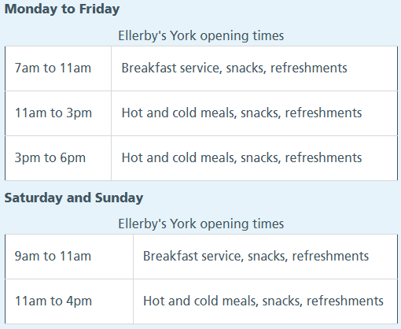

Snacks Available:

- Fruit
- Cheese and Crackers
- Fruit scone/butter
- Flapjack: traditional, chocolate, caramel, yoghurt (from the canteen)
- Caramel shortbread (from the canteen)
- Chocolate brownie (from the canteen)
- Crisps: salt and vinegar, cheese and onion,
ready salted
- Muller light yoghurts (variety of flavours)
- Thick & Creamy yoghurts (strawberry, peach)
- Ice Cream
- Mini Pack of biscuits (shortcake, oatmeal, custard cream, shortbread, bourbon)
- Chocolate bars: Kitkat’s and milky way
- Assorted cakes/slices (from the canteen)
- Granola bar (from the canteen)
- Teacake (from the canteen)
- Rocky road bar (from the canteen)
- Chocolate muffin (from the canteen)
- Lemon muffin (from the canteen)

On-Site Retail and Amenities: York

Ellerby's canteen: Monday to Friday, 7am – 6pm, Saturday and Sunday 9am – 4pm

Costa Coffee: Monday to Friday, 7am – 7pm, Saturday and Sunday 9am – 4pm

Costcutter Market Express: Monday, Wednesday, Thursday & Friday 6:30am – 7pm, Tuesday 7am – 7pm, Saturday & Sunday 9am – 5pm

York Against Cancer shop: Monday to Friday 10am – 4pm

Rowlands Pharmacy: Monday to Friday 8am – 8pm, Saturday 9am – 5.15pm, and Sunday 10am – 4pm

Chapel: Every Wednesday 12.30-1pm. 1st Wednesday of every month is communion. All welcome

Fresh Fruit Friday: Every Friday outside main reception there is a pop up fresh fruit stall. Generally 10am-3pm

24-hour access to vending machines

24-hour access to cash machine in main reception

Post Box in main reception

Outdoor space: Should you be in need of some fresh air and a change of scenery there are several outdoor spaces available to access off the main corridor of the hospital.
- Ellerby’s outside seating area
- Outside courtyard between junction 6 & 7

Local Amenities: York

Should you decide to leave the hospital grounds please advise ward staff of your intentions.
Be mindful of the risk of infection whilst in a public venue.

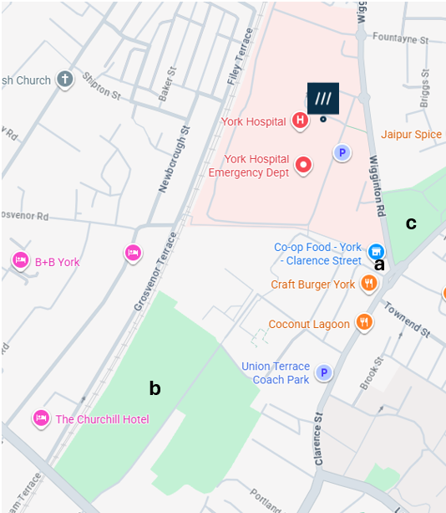

Co-op Convenience Store
Close to the hospital you will find a Co-op store. This is on Clarence Street at the junction with Wigginton Road and Haxby Road.

Bootham Park Grounds
A short walk across Trust property to a quiet grassed area. Be aware there are no benches in the grounds.

Clarence Gardens
A short walk (across a busy road junction) to a quiet garden with benches and a grassed area.

Catering Food and Snacks: Hull

Menus are provided on a daily basis and for the following day’s meals. A snack list will be provided in addition to this where a patient can choose up to five snacks per day:

- Sandwiches
- Crisps: ready salted, cheese and onion, salt and vinegar
- Biscuits: cheese and biscuits
- Chocolate bars: kit kat, mars bar
- Cakes and sweet selection: Plain scone, cake bar, flapjacks
- Thick and creamy yoghurts
- Double cream
- Milk (pint): whole or semi skimmed
- Fruit: Apples, pears, bananas, oranges

On Site Retail and Amenities: Hull

CF Team: Nursing

The CF nurse specialist will often facilitate your admission, co-ordinating with yourself, your family, bed managers, and the ward staff. We will usually see you on the ward either the day of admission, or the day after, unless it is a weekend or bank holiday. We are here to support you during your hospital stay, and to assist and support the ward nurses.

If you are admitted for intravenous (IV) antibiotics, we will organise venous access, whether it’s accessing your port a cath, or organising a midline insertion. We will support you with your IV's and have discussions with you regarding having your IV's at home, where appropriate. If you are having your IV's at home, we organise this for you and provide you with the training you need.

CF Team:

Physiotherapy

One of the CF specialist physiotherapists will see you within 24 hours of your arrival in hospital. This is usually the same day as arrival unless you arrive late in the afternoon. If you are very unwell you will be seen as soon as possible.

At admission we will go through a full assessment with you, where we will encourage you to let us know what is going well for you and what we need to look at together.

The physiotherapists will usually work with you on:
- Activity and exercise
- Airway clearance
- Inhaled and nebulised therapy
- Continence issues
- Musculoskeletal issues
- Oxygen and ventilation

You will usually be seen twice a day and at weekends if it is agreed.

We will see you at the end of your stay and talk with you about how your stay has been.

If at any point you have any queries about your physiotherapy talk to one of the physiotherapists, or a member of the CF team, so that changes can be made.

CF Team: Pharmacy

CF Team:
Clinical Psychology

What is a clinical psychologist?

Clinical Psychologists work with people who are experiencing difficulties in their lives and use evidence-based psychological therapies to support them to move forward. The York and Hull Cystic Fibrosis Centre has psychologists at both sites, and it’s likely that you’ve already met them at an MDT clinic or been invited to an annual review with them.

What problems can they help with?

Clinical Psychologists work with people who are experiencing a range of difficulties. This might include feeling low or anxious, struggling with aspects of health, treatment, or healthcare, or relate to something else entirely. For some people admission is a challenging time, and the team psychologist can support you with this if helpful.

Referral

Anyone in the team can make a referral for you to see the psychologist, you just need to let them know you would like to be referred. Every attempt is made to respond to inpatient referrals within one week, and to outpatient referrals within two weeks.
CF Team: Dietetics

The dietitian is available to see you during your inpatient stay.

We can monitor your weight while you are in and talk through any dietary issues you have.

We encourage you to try to eat and take your supplements as normal. If you have any problems with this, please let a member of nursing staff know and they can contact us.

If you need any extra snacks, bigger meal portions or more variety of meal choices we can work alongside the catering department to try to ensure you get meals that suit your needs.

Self
-Medication

It is possible to give medication yourself, and if this is preferred, please let us know. Our pharmacist will talk with you to make sure you have everything you need.

While you are in hospital, all your medication will need to be locked away. In most cases this will be in the locker by your bedside.

It is also hospital policy for the nursing staff to record what medication you have taken on your drug chart.

If you are diabetic and wish to check your own blood sugars with your own machine, rather than the nurses checking them, then please let us know. The nurses will need to record the results and therefore ask for your readings.

When you go home, we will be able to provide you with a month’s supply of your medication.

Cystic Fibrosis Trust: Financial Support Service

During your hospital admission you may have loss of earnings. The CF Trust offer financial support and advice on what you may be entitled to and can offer emergency grants to help with this.

Application forms and further advice can be downloaded from the website www.cftrust.org.uk or by telephoning the Welfare Grants Helpline: 0300 373 1020. Alternatively, you can ask a member of the CF team for an application form.

Your application will require supporting evidence from your CF team.

Discharge

Tablets to take home (TTOs)

We can provide you with a month’s supply of your medicines. If you are taking nebulised therapy that is normally dispensed by the CF team from the hospital, just let us know if you need further supplies.

Discharge letter

The ward nurses will give you a copy of the discharge letter that goes to your GP. The CF team will also write to your GP to let them know about the treatment you have received.

Follow-up appointment with the CF team

We will give you a follow-up appointment for you to come back and see the CF team, this is often within 2 weeks of discharge from hospital.

Transport home

If you are having difficulty organising transport home, please let us know. The ward can arrange a taxi for you but you will have to pay the taxi fare.

Contacting The Cystic Fibrosis Team

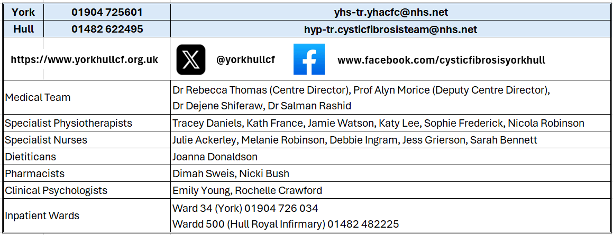

Visiting Hours

York Adult Inpatient: Ward 34 2pm-8pm

It is possible for your families to visit at any hour, however, please discuss this with either the CF team or the Nurse in Charge. Please bear in mind other patients on the ward if visiting very early or very late. In certain circumstances it may be possible to have a visitor staying overnight, there is a camp bed on the ward if required.

Visitors must sit on chairs rather than patients beds to reduce the risk of infection.

Hull Adult Inpatient: Ward 500 2pm-4pm, 7pm-9pm

It is possible for your families to visit at any hour, however, please discuss this with either the CF team or the nurse in charge. Please bear in mind other patients on the ward if visiting very early or very late.

? What happens if my heart stops/DNACPR section here?

Teaching, training, and research

Our Trust is committed to teaching, training, and research to support the development of health and healthcare in our community. Healthcare students may observe consultations for this purpose. You can opt out if you do not want students to observe. We may also ask you if you would like to be involved in our research.

Patient Advice and Liaison Service (PALS)

PALS offers impartial advice and assistance to patients, their relatives, friends and carers. We can listen to feedback (positive or negative), answer questions and help resolve any concerns about Trust services.

York PALS can be contacted on 01904 726262, or email yhs-tr.PatientExperienceTeam@nhs.net.
Hull PALS can be contacted on 01482 875875, or email pals@hey.nhs.uk.

An answer phone is available out of hours.

Martha's Law
Martha’s Rule is a patient safety initiative in the NHS that gives hospital patients, their families, and carers 24/7 access to a rapid, independent review if they feel a condition is worsening and their concerns are not being heard by the current treating team.
If you as a patient or as a relative friend are concerned, speak directly to a nurse, doctor or ward manager about your concerns and if appropriate ask for an urgent, independent clinical review.

Tell us what you think of this leaflet

We hope that you found this leaflet helpful. If you would like to tell us what you think, please contact:
York Hull Cystic Fibrosis Team, 1st Floor (above ED), York Hospital, Wigginton Road, York, YO31 8HE
Telephone: 01904 725601
Email: yhs-tr.yhacfc@nhs.net

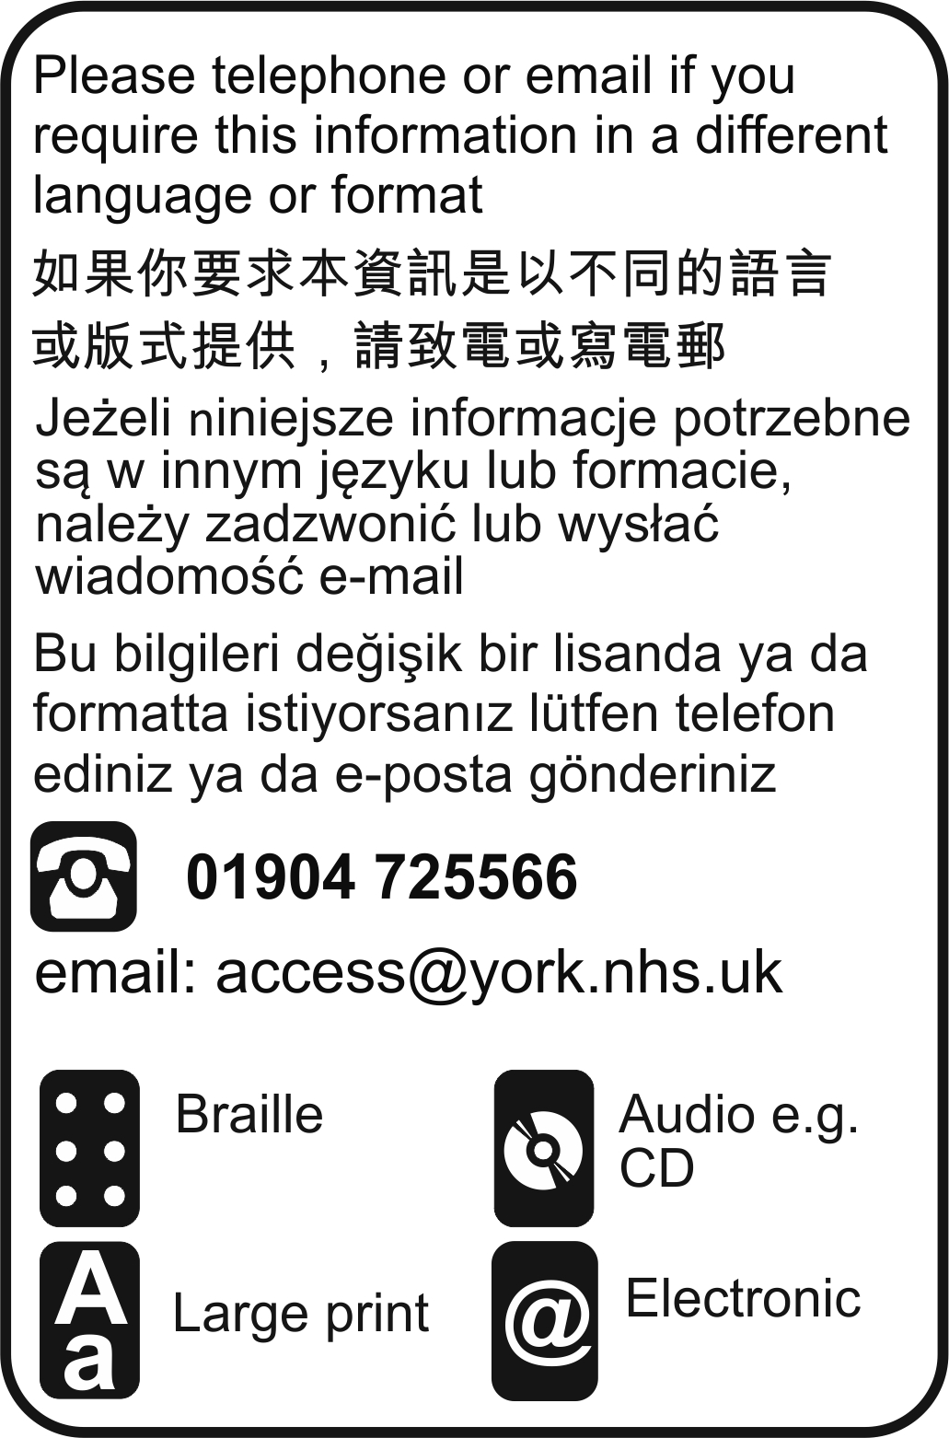

With thanks to Alice Booth for help in compiling this booklet.

Owner | Julie Ackerley, Specialist Nurse
Date first issued | September 2015
Review Date | August 2026
Version | (v3 issued August 2026-draft)
Approved by | Cystic Fibrosis Team
Document Reference | PIL 961 v3 draft
© 2019 York Teaching Hospital NHS Foundation Trust. All Rights reserved

